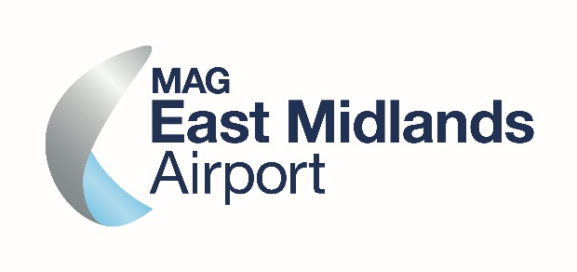
The EMA Community Sponsorship fund is to support local charities and community groups with projects and events that provide a benefit to the local community and, without support, might otherwise not be able to take place. Please read the criteria below and if you wish to apply, please complete and return this form to us by email at community@eastmidlandsairport.com
Criteria
- Requests for EMA Community Sponsorship will be considered once a month. Applications will only be considered on receipt of completed application form below.
- Funding is at the discretion of the Community Engagement Manager, who will contact you to let you know whether you have been successful in your application. You may include supporting information if you wish. Successful applicants can apply once a year
- EMA Community Sponsorship funds are to be used for financial support of a community project or event, but they cannot be used for salaries or maintenance.
- EMA Community Sponsorship must have a direct benefit to the local community
- Priority funding allocations will be given to local charities and community groups or organisations. Projects must fall within the airport ‘Area of Benefit’ as set out within the rules of our Community Fund.
- EMA Community Sponsorship cannot be given to national charities, for profit organisations or to individuals who are fund-raising.
- The maximum award is £200, however exceptions will be considered for events and projects within our nearest villages including Castle Donington, Kegworth, Melbourne, Diseworth
- For larger projects of lasting benefit please consider applying for an EMA Community Fund Grant of up to £2,000. Please visit www.eastmidlandsairport.com/community to find out about our EMA Community Fund, including full eligibility criteria and an application form.

EMA COMMUNITY SPONSORSHIP - APPLICATION FORM

Date of project or event
Name of Organisation (please include your Charity Number if applicable)

Contact Name

Telephone Number

Email Address

Where will the project be based (address including postcode)?
What are you applying for (please list specific items where possible)
How much are you applying for?
Number of people who will benefit?
Who will benefit and what will the benefit to the community be?

Project details and description
If granted, what will the award be used for?

If successful, where you would like the grant to be paid into. Please include:
Account Name, Sort Code and Account Number
How will the EMA Community Sponsorship award be recognised?
Would you like airport colleague to support your project through volunteering (if available)? If so, what would volunteers be needed for?

Please provide a quote that describes how the funding has helped your group, for use in airport social media, annual reports etc

If possible, please send us a good quality photograph of the project or event that could be used to help us promote the fund. Please ensure that all individuals pictured in photographs have given consent to their photograph being used in EMA publicity including social media. Please send any photos to community@eastmidlandsairport.com

